**CIS-350  
Infrastructure Technologies**

**Lab 1 Report**

**Student Name**: **____Spencer Kerber____**

1. Insert the *Lab1_Tree* file from p. 24 of the Lab1 instructions into the space provided or use the *Alt-PrtScr* keys to capture the full screen output (full window) from command *TYPE Lab1_Tree* on p. 24 and paste that window here.

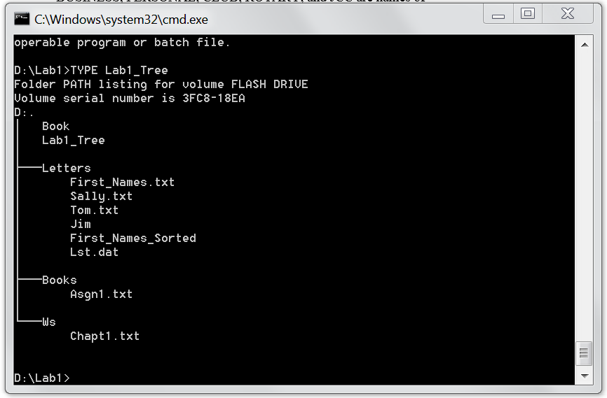

1. You have the following directory structure. ROOT (replaced by "\"), LETTERS, BOOK, BUSINESS, PERSONAL, CLUB, ROTARY, and JCC are names of directories/subdirectories, whereas MEMBER.1, MEMBER.2, and MEMBER.3 are names of files. Assume that the root directory ("\") stores the following files: *Go.bat*, *Paper1*, *Paper2*, *Paper3*, *Sheet1a*, *Sheet2*, *Sheet3*, *Sheet4*, *Shell1*, and *Shell2*. The system prompt displays"C:**\**>" which means that the current drive is C and the current directory is the root directory "**\**".



In the diagram above the word ROOT represents the root directory, i.e., "**\**". In all commands below, use the backslash "**\**" to represent the root directory. Do not to use the word ROOT. The root directory "**\**" is just the origin for other directories/subdirectories. All questions (a) through (j) are based on the above diagram.

1. Write a command to copy file *Go.bat* to directory *PERSONAL*. The copied file should have the same name as the original file.

C:\WINDOWS>COPY Go.bat F:\PERSONAL\Go.bat_______________________

1. Write a command to copy a file *Go.bat* to directory *BUSINESS*. The copied file should have new name *Go_copy.bat*.

C:\WINDOWS>COPY Go.bat F:\BUSINESS \Go_copy.bat____________

1. Write a single command to copy all files starting with *She* to directory *BOOK*.

____C:\WINDOWS>COPY She*.* F:\BOOK__________________

1. Write a single command to erase from the root directory all files that have digit *1* in their name.

_______C:\ERASE\?.*__________________________

1. How many files would be erased by the command from p. (d) above? ___10_______
2. Assume that *Paper3* is a large file. What command would you use to display the contents of the file one screen at a time (to prevent the output from scrolling off the screen)? ____MORE_________________________
3. Write two separate *SORT* commands. Both commands would accept input from file *Paper1*. However, the first command would route the output to file *Paper10*, and the second one would append the output to file *Paper10*. _ C:\WINDOWS\Paper10>SORT<Paper10____________________________________C:\WINDOWS\PAPER10>>SORT
4. Look at the diagram. Assume that prompt "C:\LETTERS\CLUB>" is displayed. Write the command which would change the current directory to JCC. ___CD JCC_______
5. Look at the diagram. Assume that prompt "C:\LETTERS\CLUB>" is displayed. In the space provided, sketch the directory structure with files which would command *TREE* /F generate.
6. Describe what a command *DIR | SORT /R > Dirlis* does.

_It lists and sorts the files in directory Dirlis ________________________________________________________________________________________________________________________

________________________________________________________________________

________________________________________________________________________

________________________________________________________________________

1. Optional. Briefly describe any issues with the commands which did not work. Point me to the specific pages and suggest changes. Thanks.